3.5 Derivative of Trigonometric Functions

Motivation:
Suppose we want to find the first derivative of . If we use the definition of the derivative, we obtain:

So, finding the derivative of sine comes down to computing two difficult limits. Specifically, we must compute: and .

Theorem: If x is measured in radians, we have:
- (2)

Proof (of 1):
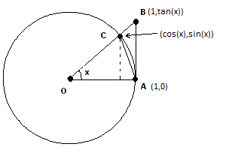
We note that since x is approaching zero we may assume that x is the measure of an acute angle. Using the figure to the right, we compute 3 different areas:

From the geometry it is clear that: which implies
Since when x is positive and near 0, we may multiply through by and obtain:. Taking reciprocals yields: .
We also see that . Therefore, by the Squeeze Theorem, we have that . A similar argument shows that from which we may conclude that .

Proof (of 2):
We rewrite the given limit as follows:

Theorem:

Proof:
Using the computation from the motivation we have that:

Note: It is CRUCIAL that x is measured IN RADIANS. The limits involved in the proof above are only valid when x is in radians. So, the derivative of sine would not be cosine if x were measured in degrees. Due to this, we always require that angles are measured in radians in calculus.

Example 1: Use the definition of the derivative to find .
(Hint: )

Using what we have shown so far we calculate:

Example 2: Use the quotient rule to find the first derivative of each of the following.

We note that:

We note that:

We note that:

We note that:

Summary of Trig Function Derivatives:

Example 3: Suppose that the position of an object on a vertical spring at time t is given by the function: . Find a function for the velocity of the object at time t.

We find the velocity by taking the first derivative of the position function. So, the answer is:

Example 4: Differentiate .

Notice that we have a product of three functions, so we will use the Product Rule. We calculate:

Note: Here we made use of two different trig. identities, namely and . It is not required that you know all such identities, but be aware that the textbook and other resources may utilize identities to simplify.

